Forecasting & Cancellation Trends
Module 4
OVERVIEW:
Module 4 provides insights into hotel booking performance trends, focusing on occupancy forecasting, cancellation patterns, booking behavior, and operational loss metrics like refunds and no-shows. The purpose of this module is to help hotel management make informed decisions on pricing, revenue management, staffing, and operational planning.

1️.Average Occupancy % by Year
This line chart displays the year-wise trend of hotel occupancy rates.

Insights:
- Occupancy shows mild fluctuations between 2020–2024, indicating seasonal and external market influences.
- Forecasting (shaded region for future years) predicts a steady rise in occupancy, suggesting increased demand and improved booking patterns.

Purpose:
- Helps management plan room pricing strategies (Revenue Management).
- Supports staffing and resource allocation based on trend expectations.
- Enables proactive forecasting for high-demand periods.
Formulas: Average Occupancy % = (Rooms Occupied ÷ Total Rooms) × 100
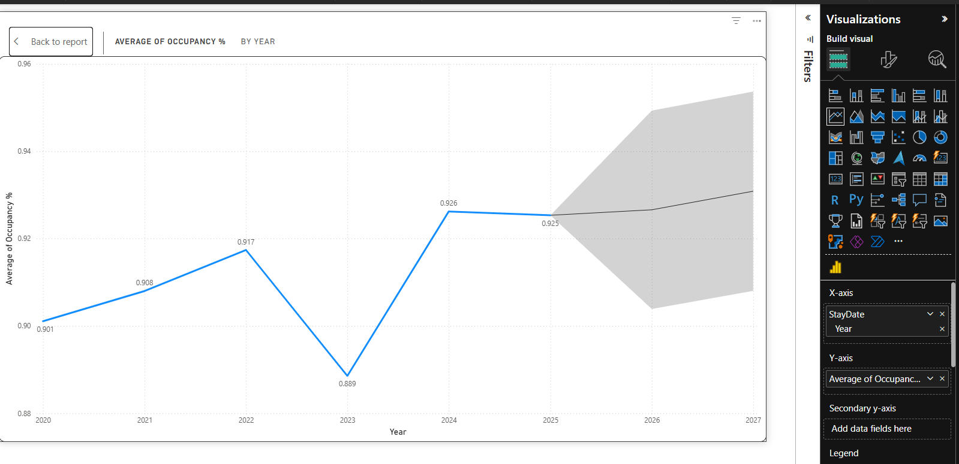

2️.Cancellation Rate Trend
This chart visualizes fluctuations in the percentage of canceled bookings over time.

Insights:
- Cancellation rate shows sharp spikes monthly, indicating variability based on promotions, events, and seasonality.
- Occasional dips reflect controlled cancellations or improved customer commitment.

Purpose:
- Helps identify months with higher cancellation risk.
- Supports creation of cancellation policies, stricter payment terms, or flexible pricing.
- Enables forecasting of possible revenue leakage.
Formulas: CancellationRate = DIVIDE(COUNTROWS(FILTER(HotelBookings, HotelBookings[CancellationFlag] = "Yes")), [Bookings])
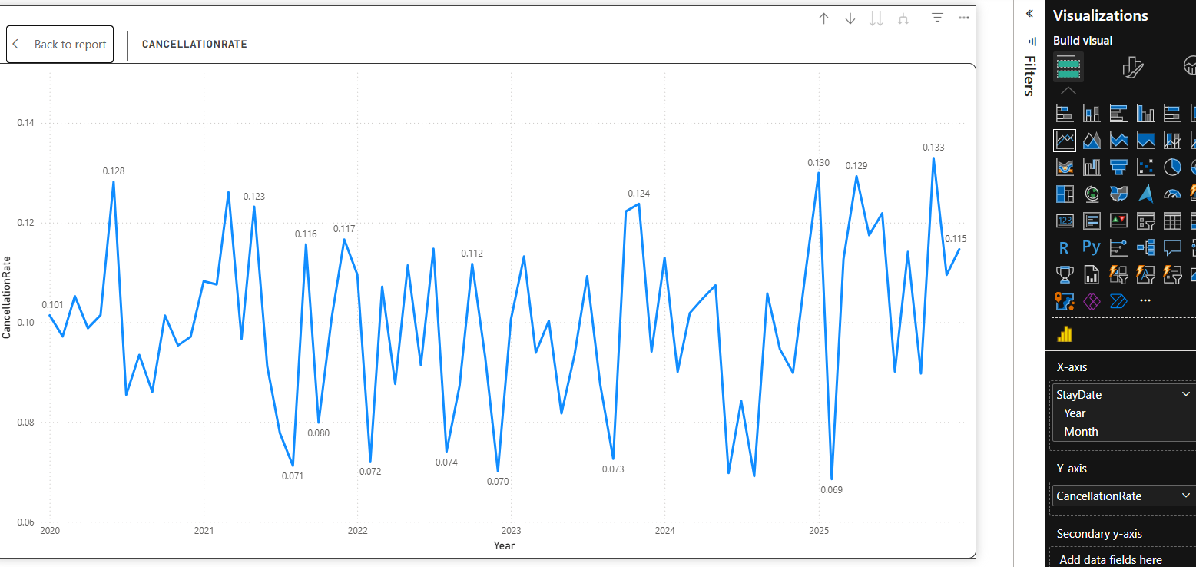

3️.Count of Bookings by Lead Time
This bar chart displays how many bookings occur based on the number of days before arrival (LeadTime).

Insights:
- Most bookings fall in the mid-range lead time, indicating balanced early and late planning behavior.
- Few extremely early or last-minute bookings signal predictable customer booking habits.

Purpose:
- Helps determine when to run promotional pricing (early bird vs. last-minute deals).
- Supports inventory blocking and forecasting models.
Formulas:LeadTime = DATEDIFF(HotelBookings[BookingDate], HotelBookings[CheckInDate], DAY)
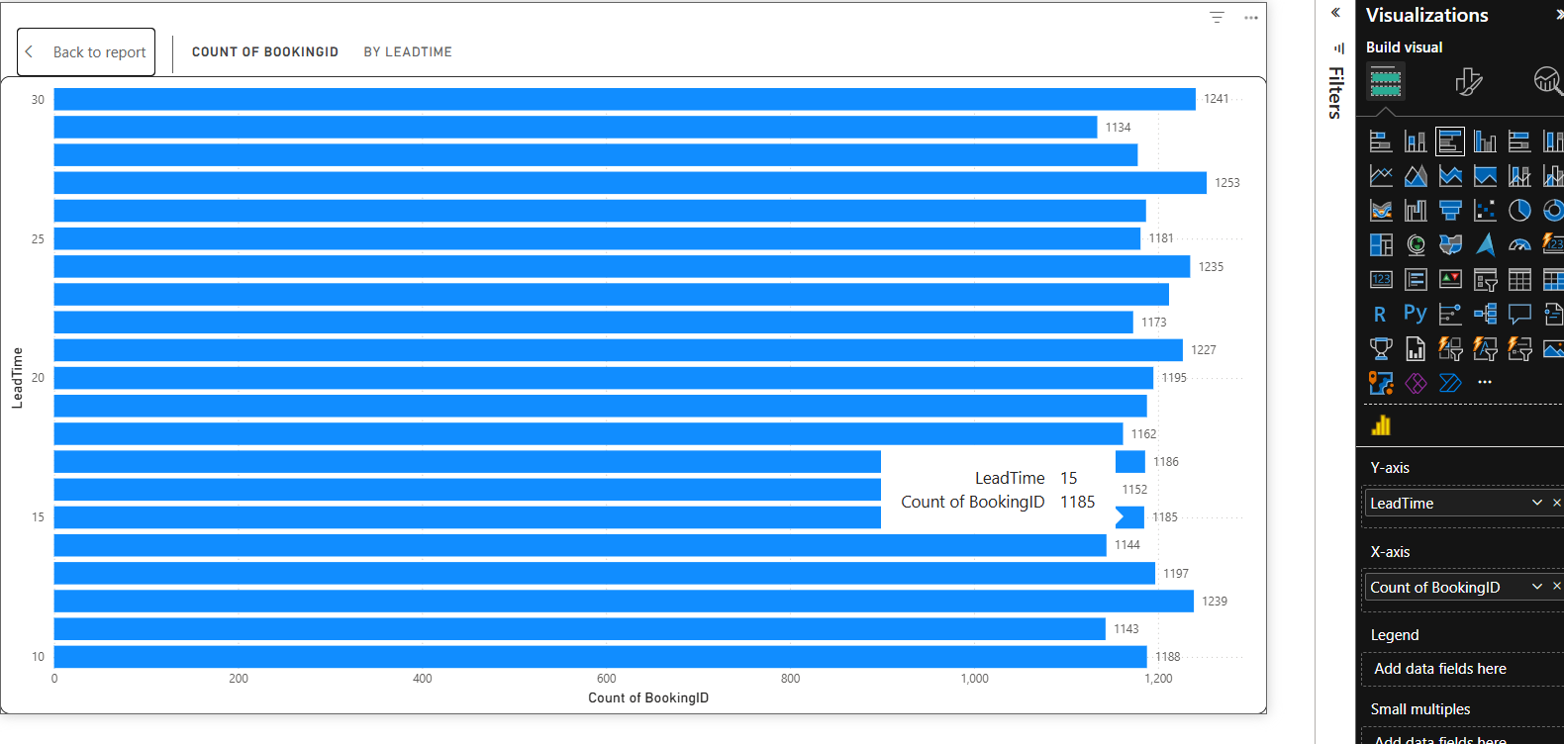

4️.Refund Count vs No-Show Count by Year
This stacked percentage chart compares annual trends in Refunded bookings and No-Shows.

Insights:
- No-shows and refunds together account for approximately 17%–22% of total bookings.
- Refund trend shows slight yearly variations, while no-shows remain consistent.

Purpose:
- Helps calculate lost revenue and define mitigation strategies.
- Useful for improving payment terms, pre-payment rules, and communication tactics.
Formulas:
NoShowCount = CALCULATE(COUNTROWS(HotelBookings), HotelBookings[BookingStatus] = "No-Show")
RefundCount = CALCULATE(COUNTROWS(HotelBookings), HotelBookings[RefundAmount] > 0)
